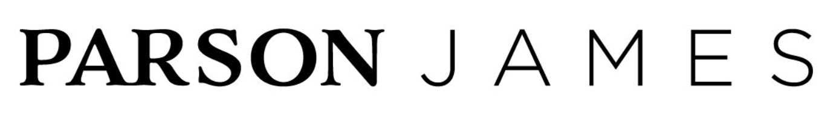
PARSON JAMES RETURNS WITH BRAND NEW SINGLE & VISUAL,
‘HIGH TIDE, LOW TIDE’ -- OUT TODAY VIA 12TONE MUSIC

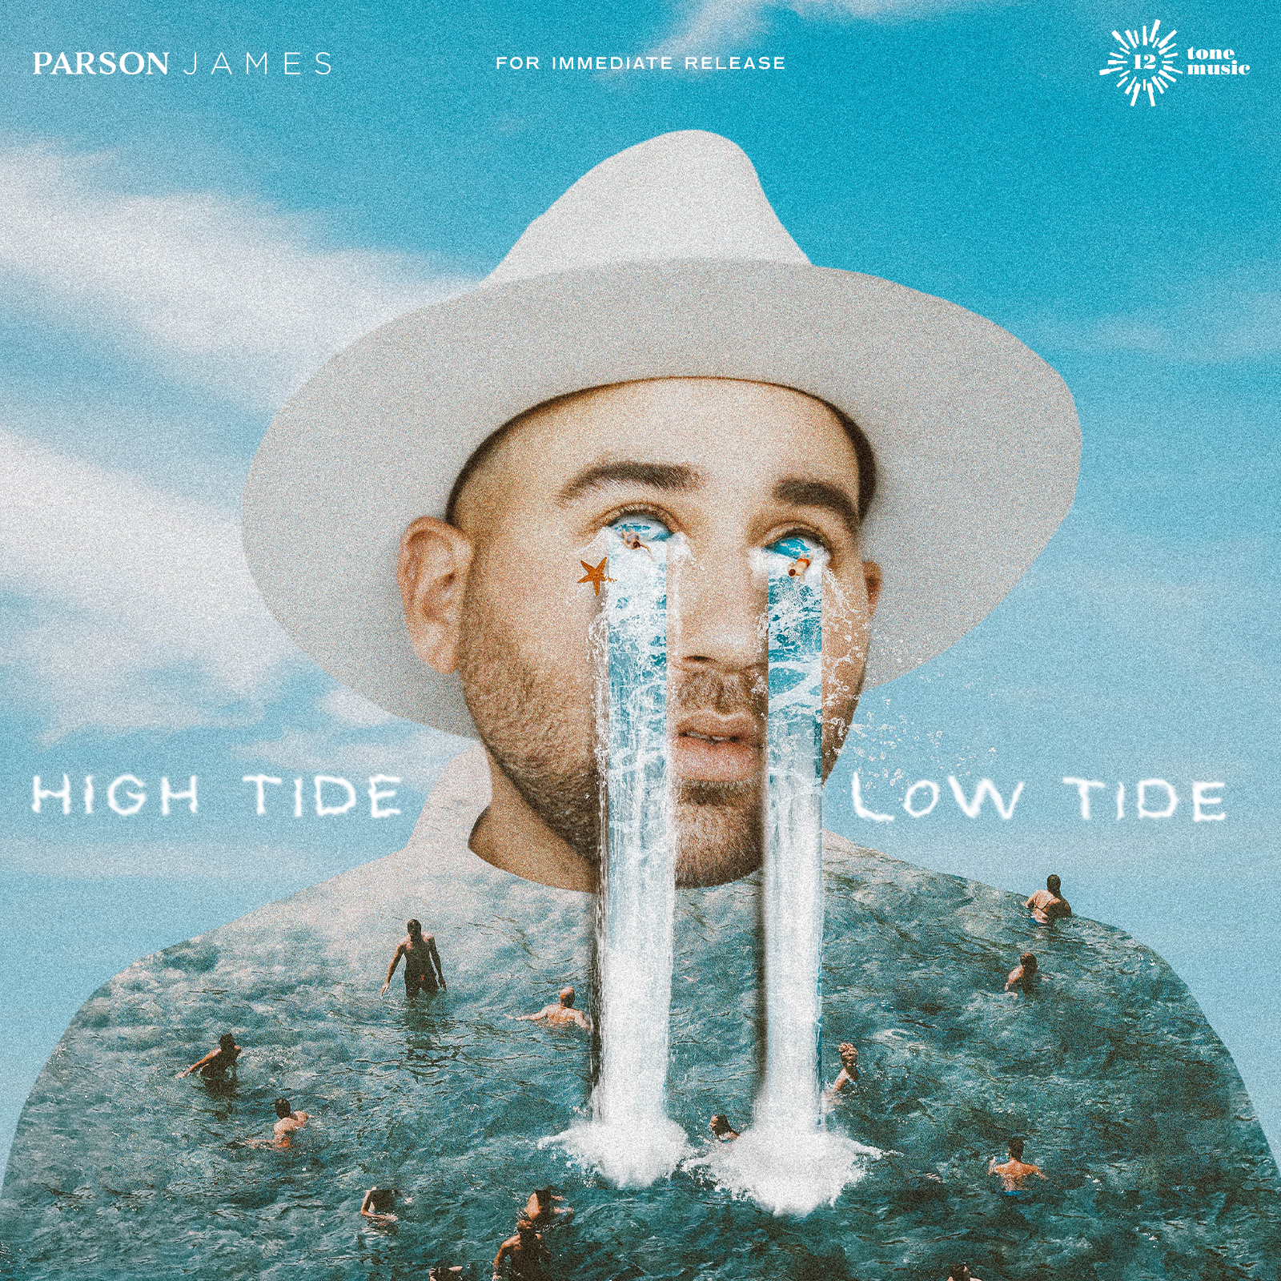

WATCH | LISTEN
‘HIGH TIDE, LOW TIDE’

Multi-platinum selling artist Parson James has returned today with his brand new single ‘High Tide, Low Tide,’ also marking the first release since signing to his new record label 12Tone Music.

“’High Tide, Low Tide’ actually came about during the throes of quarantine. It’s clearly been an exceptionally odd year for everyone and personally it’s forced me to look inward and face things about myself in a way that I had never done before.” Parson James confesses. “As always, a hunter for silver linings, I am thankful for what I’ve learned during this time. The opening line of the song is “my empathy is killing me” & what I mean by that is that my empathy is always getting the best of me. I’m always trying to help others before ever helping myself and more often than not this does not work in my favor.” Read Parson James’ full interview and learn more about the inspiration behind the song in V Magazine HERE

Listen to ‘High Tide, Low Tide’ HERE

Watch the visual for ‘High Tide, Low Tide’ HERE

With his cathedral-size vocal range, confessional lyricism, sharp sense of soul, and pop ambition, South Carolina-born and Los Angeles-based platinum-certified singer and songwriter Parson James transmutes trials and tribulations into inspiration.

Now, with a new label deal and single out titled “High Tide, Low Tide,” Parson James is ready to wear his heart on his sleeve yet again, as he embarks on this next chapter. His rhythmically soulful way of storytelling permeates throughout his new music, setting the stage for Parson James to return with a style that is finally his own. “It’s a focus on me, now. I’m at this point in my life, where I’m back at a place of total belief in myself,” he says. “I’m stoked to be able to have creative control, clarity and freedom to continue telling my story.”

Parson’s personal journey could be worthy of a novel or screenplay in and of itself. As an openly gay, bi-racial son of the South, who experienced a rocky childhood marked by racism, religion-based homophobia, addiction, and domestic abuse, James has frequently found himself drawn to trying to make sense of his past and how it has shaped his identity. Born to an African American father and Caucasian teen mom in poverty, the music of Otis Redding, Bill Withers, Johnny Cash, and Elvis Presley became something of a refuge throughout his childhood.

Following a whirlwind few years starting in 2015 when Parson James catapulted to the top of the charts and gained instant global fame having penned and sang on Kygo’s major hit “Stole The Show,” he simultaneously inked a major label deal, began releasing his own critically acclaimed solo music, landing on the cover of magazine’s and touring all over the world. “Stole The Show” went on to earn RIAA multi-platinum certification in North America and multi-platinum in 15 other countries, clocking more than a billion combined global streams.

Also, a staunch and outspoken advocate, he capitalized on the opportunity to give back within the LGBTQ+ community and became a board member for the LOVELOUD Foundation, and has been a regular contributor to organizations such as GLAAD, The Trevor Project and AmFAR.

Now, Parson James is back, with more experience, a new perspective and the best music he’s written to date.

INSTAGRAM | TWITTER | FACEBOOK

For all media inquiries, please contact:
Lydia Kanuga | Lydia.Kanuga@12tonemusicgroup.com
Alexandra Baker | Alexandra@highrisepr.com
Jamie Sward | Jamie@highrisepr.com

