PLATINUM CROSSOVER ELECTRONIC ARTIST AND PRODUCER/DJ ILLENIUM RELEASES HIGHLY ANTICIPATED VIDEO FOR “NIGHTLIGHT” VIA 12TONE MUSIC
Watch HERE

“NIGHTLIGHT” AT OVER 4.5M COLLECTIVE STREAMS TO DATE

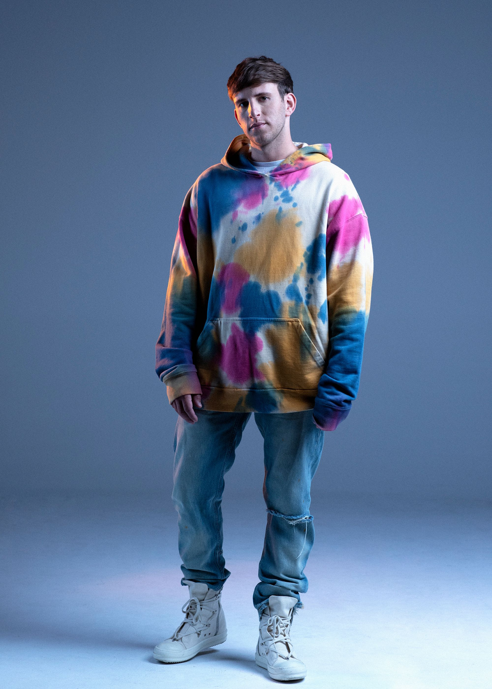

(New York, NY - September 15, 2020) Platinum crossover electronic artist and producer/DJ ILLENIUM has released the highly anticipated video for his single “Nightlight”. The single is his first release via his recent partnership with 12Tone Music, led by industry veterans Doug Morris and Steve Bartels and has over 3M global streams in the first week of release and over 4.5M collective streams to date. Currently the song is the #1 gainer at dance radio. Of the video directed by Najeeb Tarazi, ILLENIUM states “This music video means a lot to me because I feel like it’s the beginning of a new chapter and the start of a story that will continue to unfold through my music.”

“Nightlight” is ILLENIUM’s first single since “Feel Something” with Excision, and his 2019 album Ascend, which has over 1 billion streams and became his first number one on the Billboard Top Dance/Electronic Albums chart, reaching his highest peak on the Billboard 200. His 40-date North American Ascend headline tour featured a massive production consisting of a five-piece live band and sold out landmark venues including Madison Square Garden, STAPLES Center, Chase Center, and three consecutive nights at the legendary Red Rocks Amphitheatre.

As one of the most successful crossover electronic artists today, Denver-based producer/DJ ILLENIUM, née Nick Miller, has elevated dance music via his bold, progressive take on the genre. His expansive sound, which mixes elements of celestial electronic, mellow alternative, rock-fuel dubstep, emotional indie and pop-tinged bass music, has topped the U.S. charts, and garnered more than 4 billion collective streams.

Facebook | Twitter | Instagram

Press Contact:
Lydia Kanuga
Lydia.Kanuga@12tonemusicgroup.com

