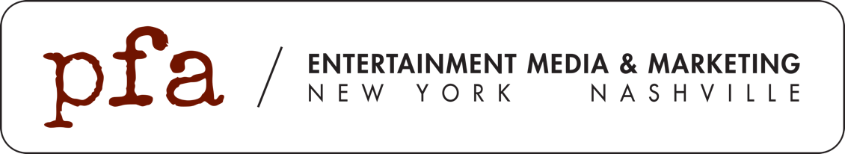

FOR IMMEDIATE RELEASE
September 16, 2019

LAUREN DAIGLE KICKS OFF 2020 WITH FIRST HEADLINING ARENA TOUR
“LAUREN DAIGLE WORLD TOUR”

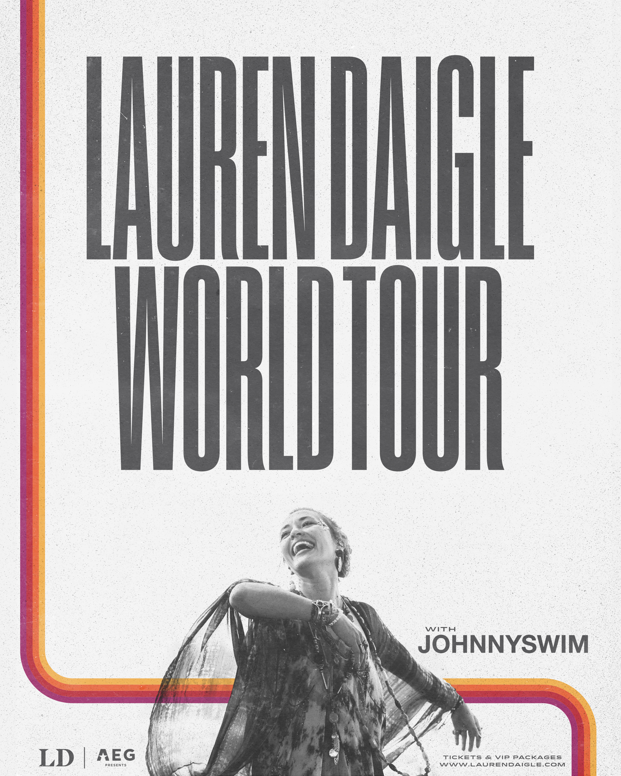

Tickets On Sale Friday, September 20th

Two-time GRAMMY Award winner Lauren Daigle, who has sold out every one of her shows to date, will open 2020 with her first headlining arena tour, the “Lauren Daigle World Tour.” It follows nearly 70 sold out performances that have taken place since the release of her GRAMMY Award winning album, Look Up Child.

The forty four-city “Lauren Daigle World Tour,” kicks off January 18th in Melbourne, Australia and will include a performance at New Zealand’s Festival One. It will then launch in the US on February 20th in Pensacola, Florida and will include stops in New York, Nashville, Houston, Boston, Dallas and north of the border in Toronto and Montreal. The “Lauren Daigle World Tour” wraps with a special performance in Lauren’s hometown of Lafayette, LA at the CAJUNDOME.

American Express® Card Members can purchase tickets in the U.S. and Canada before the general public beginning Tuesday, September 17th at 12 PM local time through Thursday, September 19th at 10 PM local time. A limited number of VIP Packages will be available to purchase. These exclusive offers include an amazing selection of tickets, access to a preshow song performance and Q&A with Lauren Daigle, a limited-edition tour poster, custom merchandise and more! Tickets will go sale to the general public in US & Canada on September 20th at 10 am local time at www.laurendaigle.com/tour

“This year has been life changing,” said Daigle. “There’s no better feeling than to be able to look out from the stage and see how people have connected with the songs on this album. Our shows feel like one big party of togetherness, and I can’t wait to create a whole new tour for 2020. It’s going to be so much fun!”

The “Lauren Daigle World Tour” features an all new stage production, design and set list that will be highlighted by Daigle’s raw vocal power and stage presence. She’ll feature some of her hits, including her latest single “Rescue” and the double-Platinum selling #1 single “You Say,” as well as tracks from her previous platinum-selling album, How Can It Be. Folk/soul duo JOHNNYSWIM will join Daigle on select US dates.

To exclusively announce the upcoming dates, iHeartMedia’s LiteFM on-air personalities, Cubby and Christine, hosted an iHeartRadio Special Announcement with Daigle at iHeartMedia headquarters in New York. The event included an intimate performance and Q&A which streamed live on iHeartRadio’s YouTube. In addition, iHeartMedia will broadcast portions of the Q&A on LiteFM on September 17th.

All U.S. and Canadian performances are being promoted and presented by AEG Presents. Australian and New Zealand dates are promoted by Live Nation except for Festival One.

Connect with Lauren:
Website // Facebook // Instagram // Twitter // Youtube

Lauren Daigle World Tour
DATE | VENUE | CITY
January 18th | Palais Theatre | Melbourne, VIC, Australia
January 19th | Enmore Theatre | Sydney, NSW, Australia
January 22nd | Fortitude Music Hall | Brisbane, QLD, Australia
January 24th | Festival One | Hamilton, New Zealand
January 25th | James Hay Theatre | Christchurch, New Zealand
February 20th | Pensacola Bay Center | Pensacola, FL
February 21st | VyStar Veterans Memorial Arena | Jacksonville, FL
February 22nd | Bojangles’ Coliseum | Charlotte, NC
February 27th | Bon Secours Wellness Arena | Greenville, SC
February 28th | Thompson-Boling Arena | Knoxville, TN
February 29th | Greensboro Coliseum | Greensboro, NC
March 5th | American Airlines Center | Dallas, TX
March 6th | Chesapeake Energy Arena | Oklahoma City, OK
March 7th | CenturyLink Center | Bossier City, LA
March 12th | Van Andel Arena | Grand Rapids, MI
March 13th | Ford Center | Evansville, IN
March 14th | Grossinger Motors Arena | Bloomington, IL
March 15th | Huntington Center | Toledo, OH
April 30th | Rupp Arena | Lexington, KY
May 1st | Berglund Center | Roanoke, VA
May 7th | State Farm Arena | Atlanta, GA
May 8th | Amway Center | Orlando, FL
May 9th | BB&T Center | Sunrise, FL
May 14th | CHI Health Center | Omaha, NE
May 15th | Target Center | Minneapolis, MN
May 16th | Denny Sanford PREMIER Center | Sioux Falls, SD
May 28th | Sprint Center | Kansas City, MO
May 29th | Chaifetz Arena | St. Louis, MO
May 30th | Resch Center | Green Bay, WI
June 18th | Allstate Arena | Rosemont, IL
June 19th | Allen County War Memorial Coliseum | Fort Wayne, IN
June 20th | Bridgestone Arena | Nashville, TN
June 25th | Madison Square Garden | New York, NY
June 26th | Agganis Arena | Boston, MA
June 27th | XL Center | Hartford, CT
July 1st | Mohegan Sun Arena at Casey Plaza | Wilkes-Barre, PA
July 2nd | Scotiabank Arena | Toronto, ON
July 3rd | Bell Centre | Montreal, QC
July 9th | PPG Paints Arena | Pittsburgh, PA
July 10th | Giant Center | Hershey, PA
July 11th | Scope Arena | Norfolk, VA
July 16th | Toyota Center | Houston, TX
July 17th | Frank Erwin Center | Austin, TX
July 18th | CAJUNDOME | Lafayette, LA

For More Information Contact:
Paul Freundlich // PFA Media // 212-334-6116 // paulf@pfamedia.net
Alicia Brown // PFA Media // 212-334-6116 // abrown@pfamedia.net

