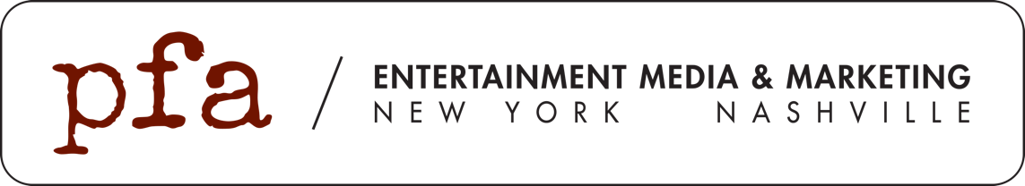

FOR IMMEDIATE RELEASE
February 10, 2019

LAUREN DAIGLE CELEBRATES FIRST
GRAMMY© AWARD WIN - TWICE

Platinum selling artist Lauren Daigle can add GRAMMY© Award Winner to her list of accomplishments after taking home awards for her Billboard Hot 100 Single “You Say” and Billboard Top 200 Album, “Look Up Child.” It’s already been a banner year for Daigle, whose GRAMMY© Award Winning album debuted at No. 3 on the Billboard Top 200 Album Chart and earned her an American Music Award.

Of her win(s), Daigle said, “I love that music gives us the opportunity to “Look Up” and enjoy life. It’s such a gift to not only be a part of the musical community, but to be able to share my music with my fans. Thank you to everyone that allows me to do what I love. See you on the road!!!!”

The second leg of Daigle’s sold out Look Up Child tour kicks off this Thursday at the Paramount Theatre in Seattle, WA.

Connect with Lauren:
Website // Facebook // Instagram // Twitter // Youtube

