For Immediate Release:

NEFFEX RELEASE HIGHLY ANTICIPATED DEBUT EP
Q203 TODAY VIA 12 TONE MUSIC

“[The Q203 EP] displays the diverse influences that
define NEFFEX’s artistic palette.” - FORBES

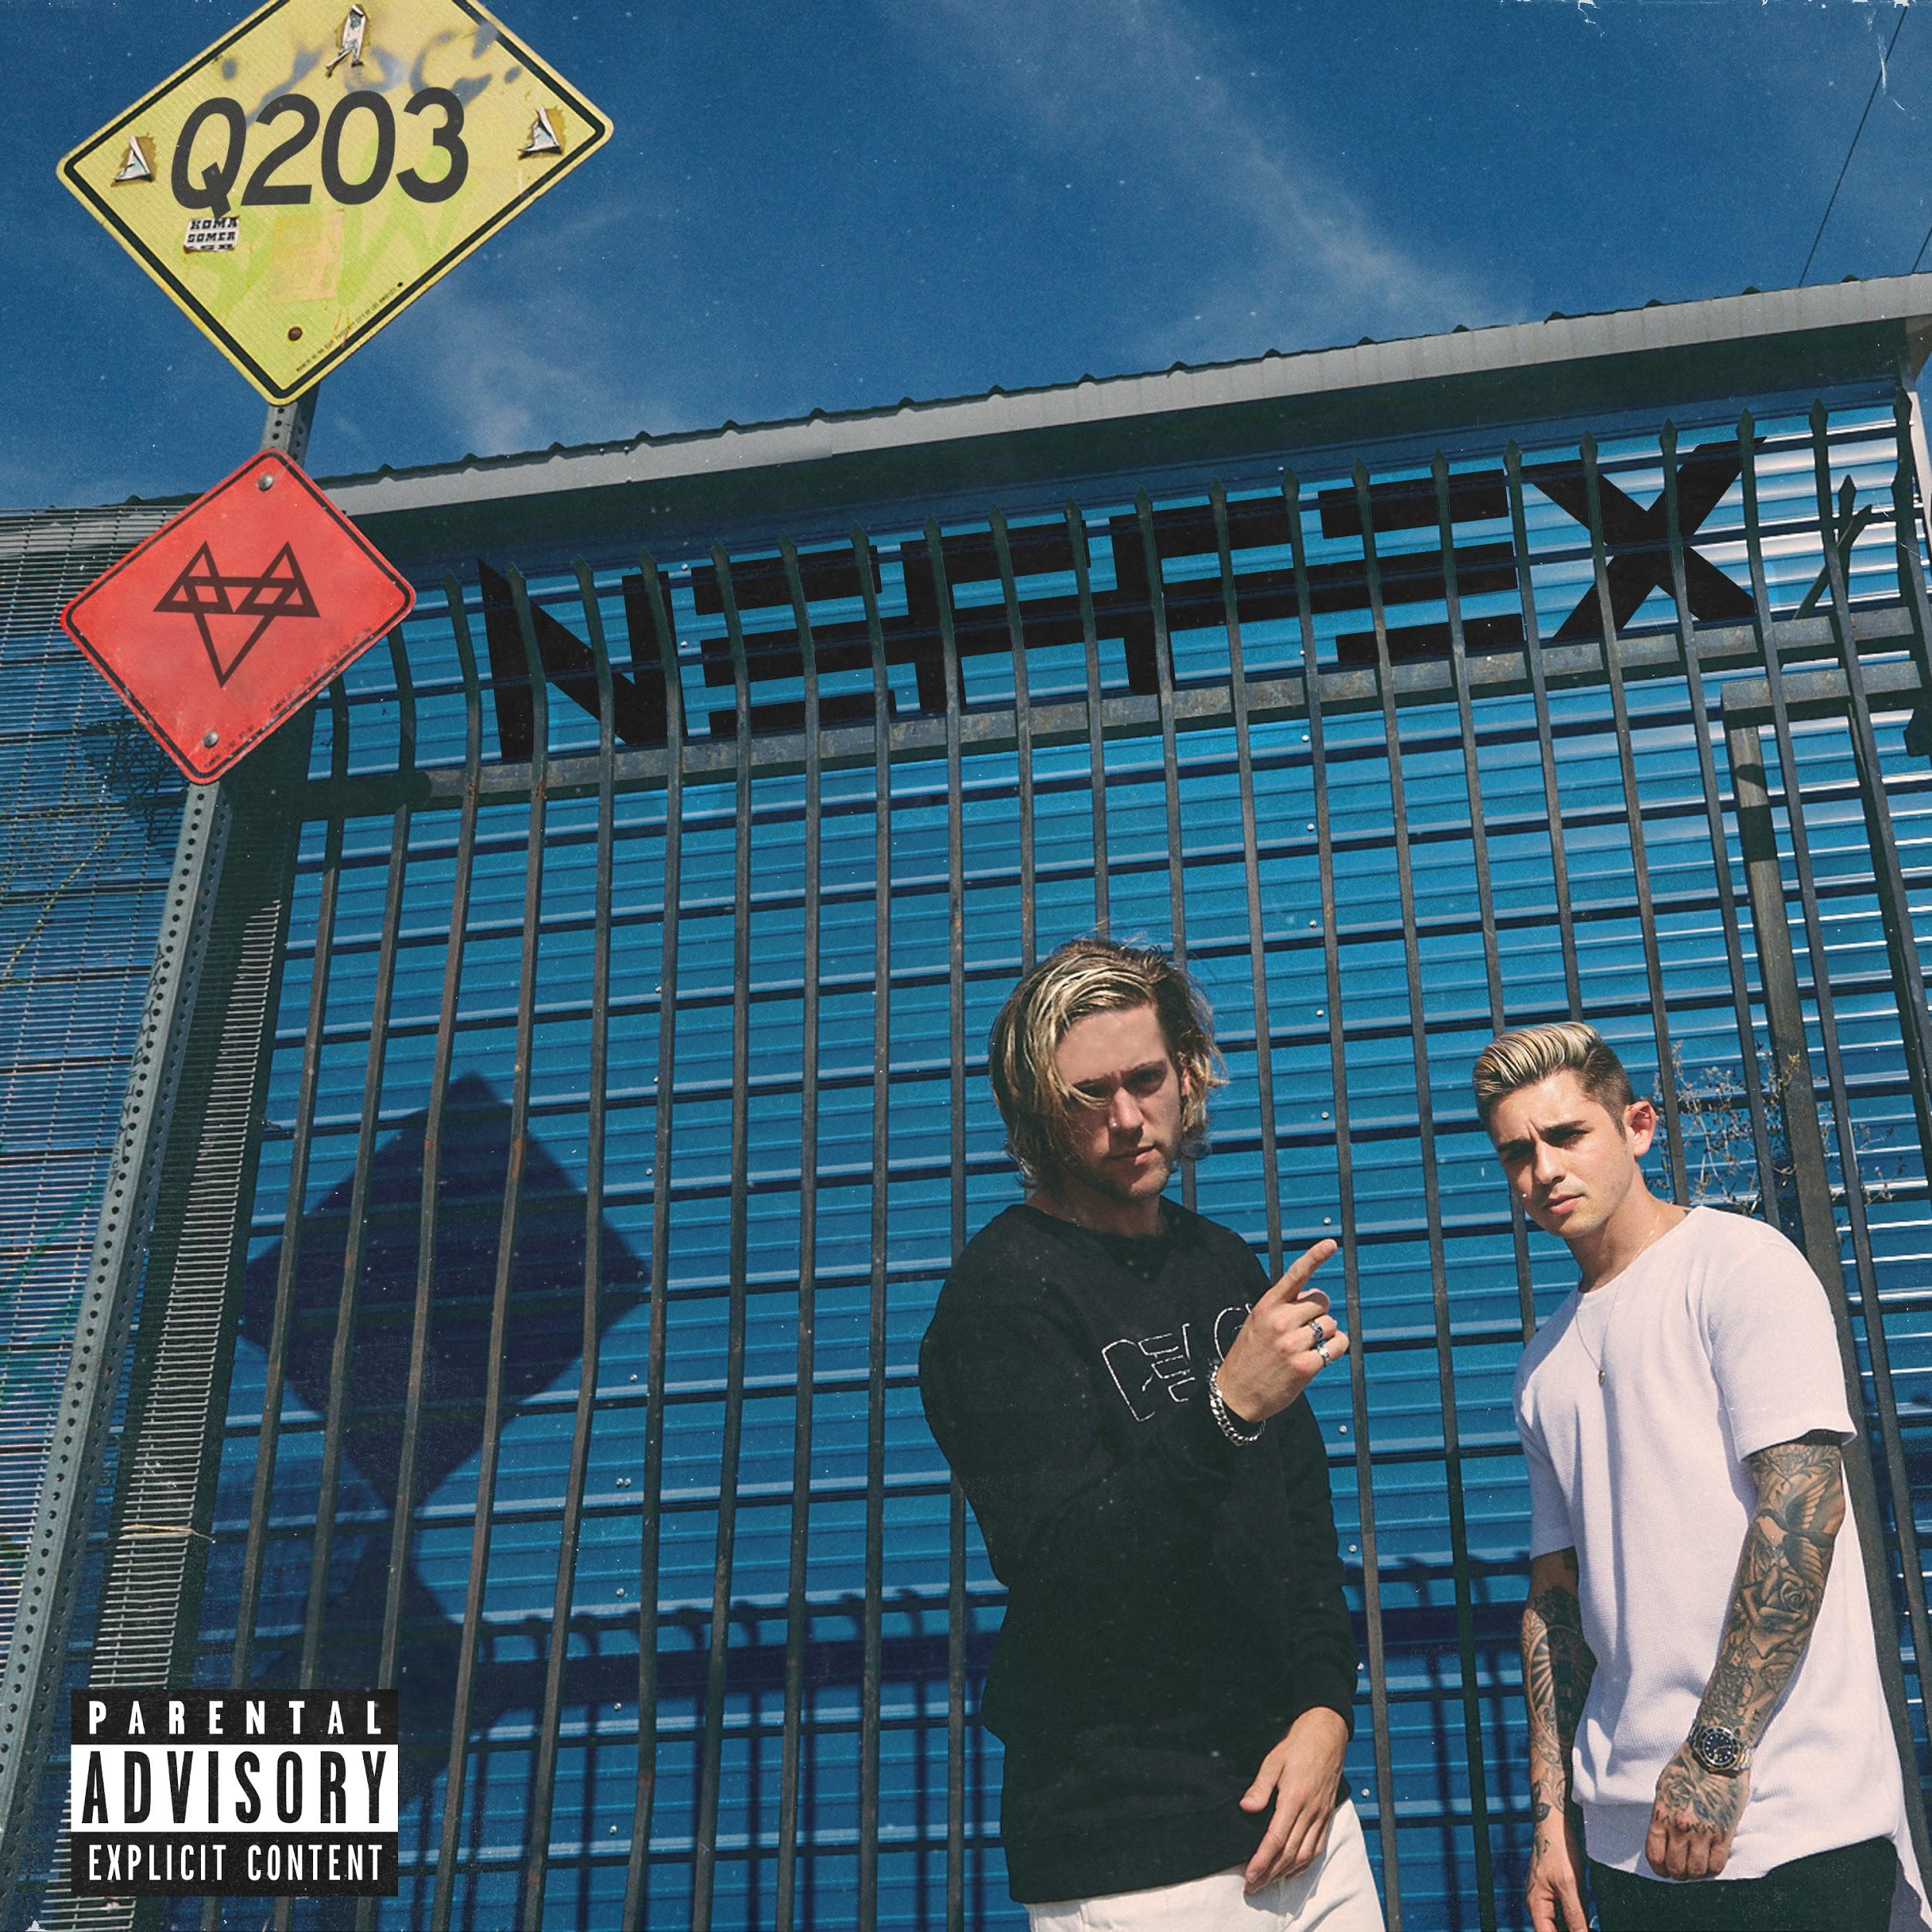
NEFFEX - Q203 EP (Artwork courtesy of 12 Tone Music)

Los Angeles, CA (October 16, 2019) - Southern California duo NEFFEX have officially released their debut EP Q203 today via 12 Tone Music. The genre-shattering EP features a collection of songs that push the boundaries of pop, rock, hip hop and electronic music, including the previously released singles “It’s My Life” and “Sunday”. The group has garnered the attention of Billboard and Idolator, and most recently were featured by Forbes in an exclusive interview. The Q203 EP is available now via digital streaming platforms everywhere HERE.

“Q203 pays homage to the apartment where we made the 100 songs in 100 weeks and the music that the fans discovered and love us for,” said the group. “We wanted to make sure this project was a summation of our whole catalogue from a genre standpoint, and of course give them the best music we can.”

Signed to 12 Tone Music in 2019, NEFFEX are igniting their next chapter with the Q203 EP. Written, produced and mixed entirely by the group themselves, the release is aptly titled after the apartment where the duo first built their own DIY recording studio and began writing songs together. To celebrate the EP release, NEFFEX kicked off a highly anticipated fall European tour last night at Mascotte in Zurich, Switzerland.

Q203 EP TRACKLISTING
- When I Was Young
- Without You
- It’s My Life
- Sunday
- Primal
- Want Me

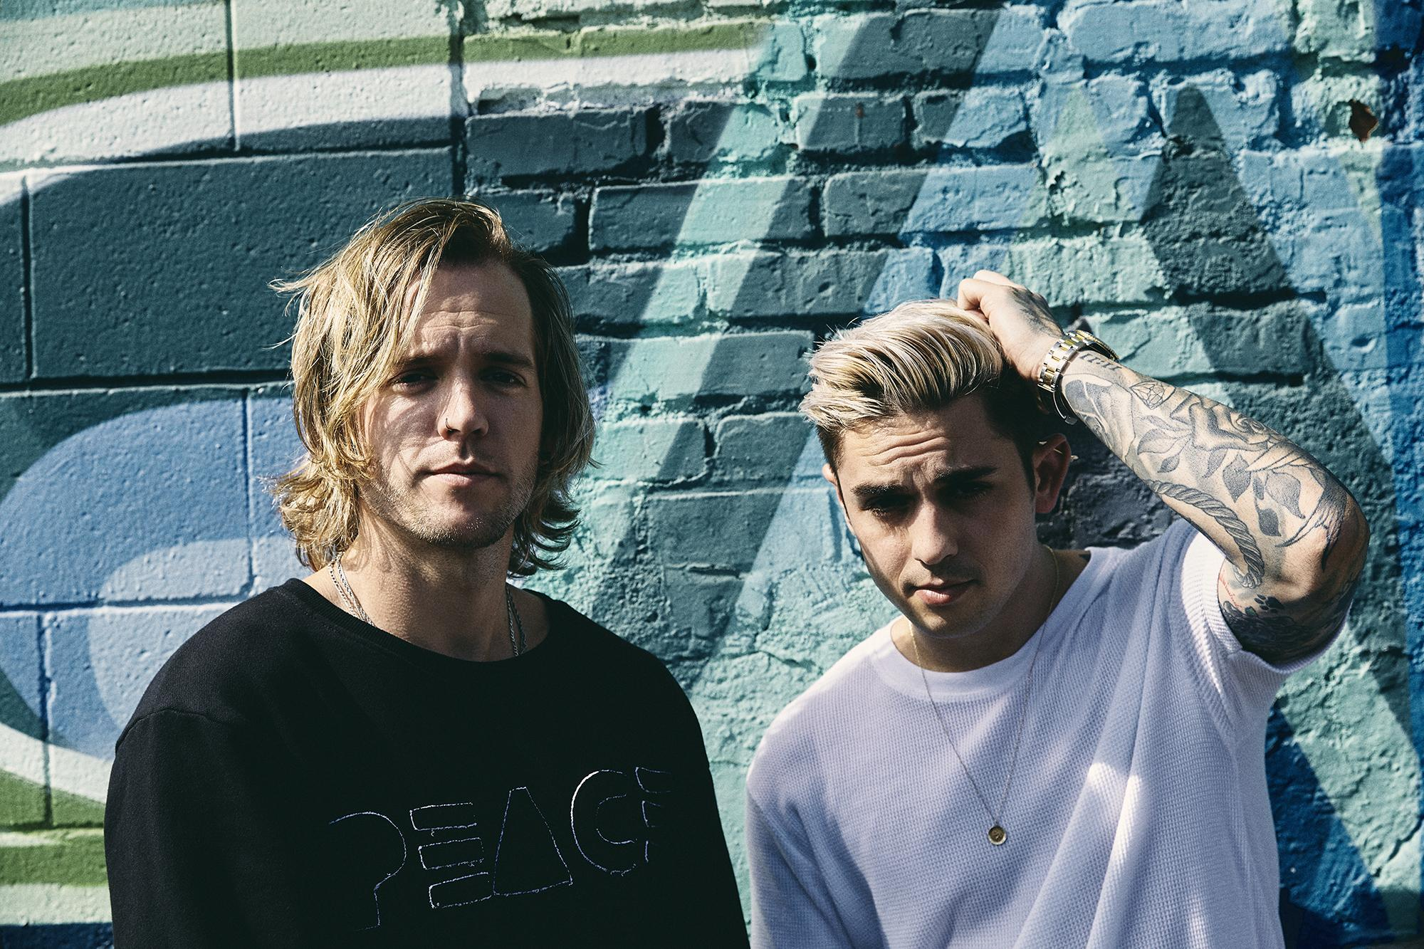
Neffex (Photo Credit: Jonathan Weiner)

###

ABOUT NEFFEX
The NEFFEX story might be the only thing more unique than the Southern California duo’s genre-shattering music. In 2017, the pair of lifelong friends—Bryce Savage [vocals] and Cameron Wales [guitar, DJ]—decided to release an original song every Wednesday at 9am for 100 weeks, fully produced and recorded from their apartment Q203. They were inspired by their love for creating music and admiration for the work produced by artists like Lil Wayne and Russ. Using their own innovative twists and D.I.Y. spirit, they went even further and shared their music, royalty-free, with hundreds of YouTube channels, influencers, and blogs. Their songs exploded in popularity and, by the end of 2018, they had unleashed over 110 originals, plus remixes, that blended the sonic worlds of guitar- driven pop, alternative, electronic and hip-hop. NEFFEX is now igniting its next chapter with their highly anticipated debut EP Q203 and a European tour this fall.

